AWS Automation with Lambda & Boto3
_____________________________________________________________________________________________________
3. Auto-Tagging EC2 Instances on Launch
Objective: Automatically tag newly launched EC2 instances for resource tracking, ownership, and cost allocation.
Instructions:
---------------------------------------------------------------------------------------------------------------------------------------------------------------------------

Step 1 – Create IAM Role for Lambda
Go to:
IAM
→ Roles
→ Create Role
Choose:
AWS Service
Select:
Lambda
Click Next.
Role Name:
EC2AutoTagLambdaRole
Click Create Role.

Step 2 – Attach CloudWatch Policy
Attach the AWS managed policy:
AWSLambdaBasicExecutionRole
This enables Lambda to write logs to CloudWatch.

Step 3 – Add Inline IAM Policy
Open the role.
Navigate to:
Permissions
→ Add Inline Policy
→ JSON
Paste:
{
"Version": "2012-10-17",
"Statement": [
{
"Sid": "EC2TagPermissions",
"Effect": "Allow",
"Action": [
"ec2:CreateTags",
"ec2:DescribeInstances"
],
"Resource": "*"
}
]
}
Save the policy.

Step 4 – Create Lambda Function
Open:
AWS Lambda
Click:
Create Function
Choose:
Author from Scratch
Configure:
Setting | Value
Function Name | EC2AutoTag
Runtime | Python 3.12
Execution Role | Use Existing Role
Role | EC2AutoTagLambdaRole
Click Create Function.

Step 5 – Lambda Python Code
Replace the default code with:
import boto3
from datetime import datetime

ec2 = boto3.client("ec2")

def lambda_handler(event, context):

# Extract instance ID from EventBridge event
instance_id = event["detail"]["instance-id"]

launch_date = datetime.utcnow().strftime("%Y-%m-%d")

ec2.create_tags(
Resources=[instance_id],
Tags=[
{
"Key": "LaunchDate",
"Value": launch_date
},
{
"Key": "Environment",
"Value": "Development"
}
]
)

print(f"Successfully tagged instance {instance_id}")

return {
"InstanceId": instance_id,
"Status": "Tagged"
}
This Lambda:
- Reads the EC2 instance ID from the EventBridge event.
- Adds the LaunchDate tag.
- Adds a custom Environment tag.
- Prints a confirmation message to CloudWatch Logs.

Step 6 – Deploy Lambda
Click:
Deploy

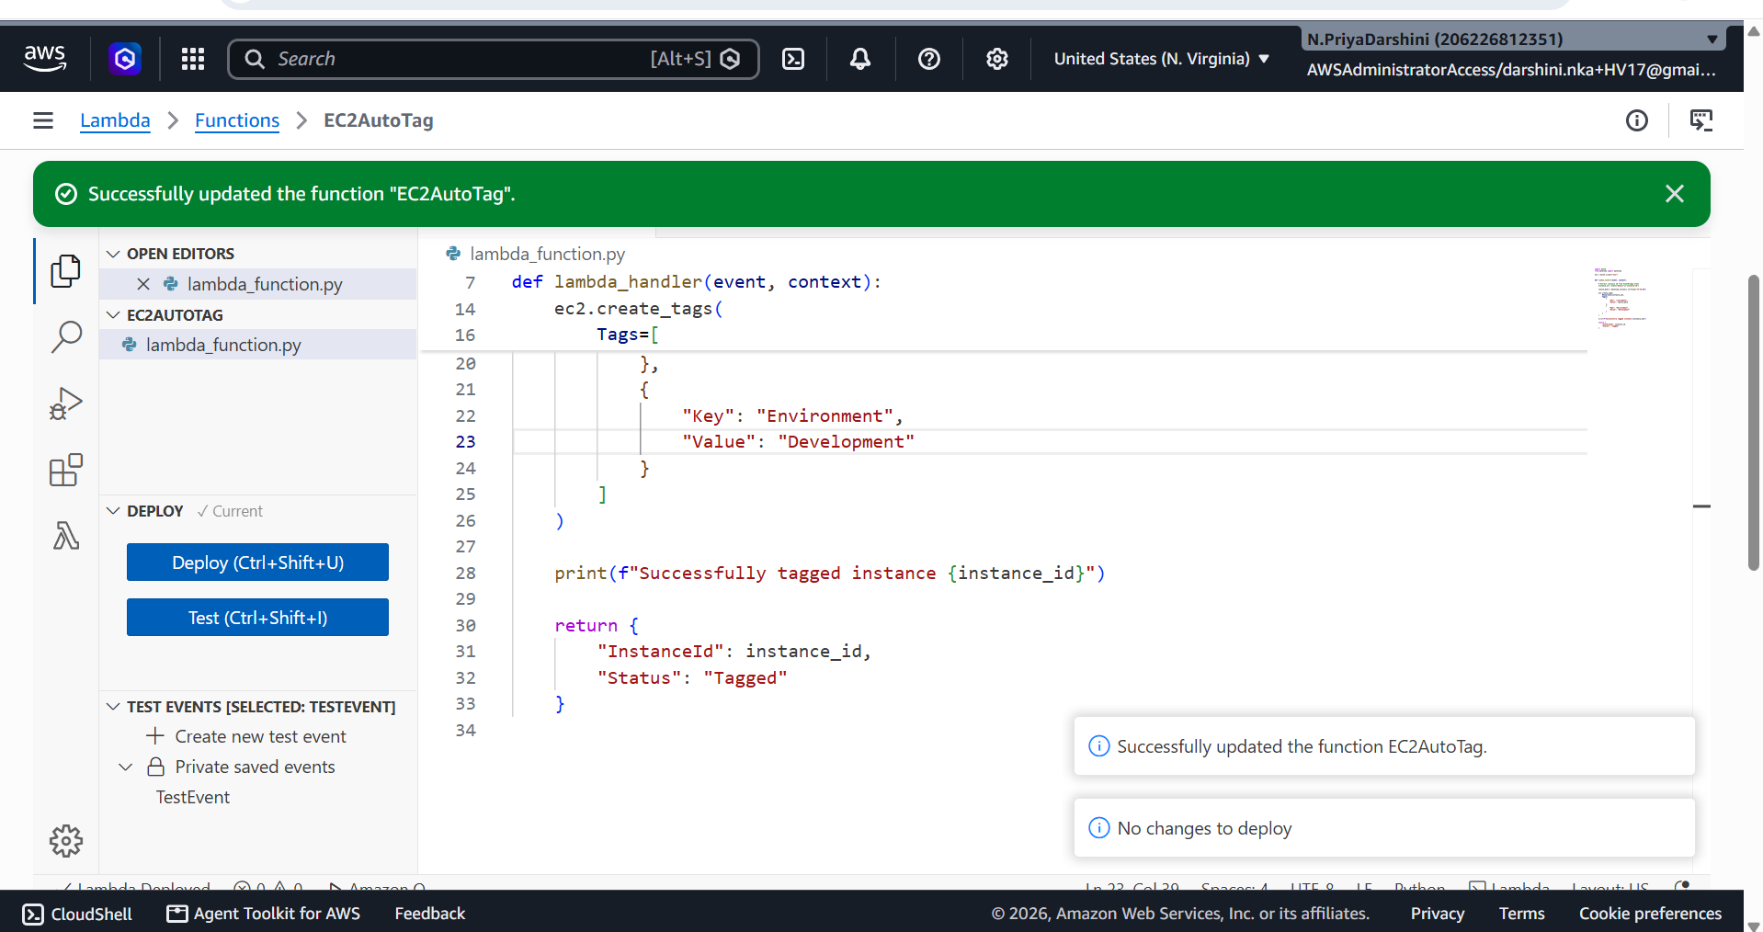

Step 7 – Create EventBridge Rule
Open:
Amazon EventBridge
Go to:
Rules
→ Create Rule
Configure:
Setting | Value
Rule Name | EC2AutoTagRule
Event Bus | Default
Rule Type | Rule with Event Pattern
Click Next.

Step 8 – Configure Event Pattern
Choose:
AWS Events
Service:
EC2
Event Type:
EC2 Instance State-change Notification
State:
running
Equivalent JSON event pattern:
{
"source": [
"aws.ec2"
],
"detail-type": [
"EC2 Instance State-change Notification"
],
"detail": {
"state": [
"running"
]
}
}
Click Next.

Step 9 – Add Lambda Target
Target:
Lambda Function
Choose:
EC2AutoTag
Click:
Create Rule

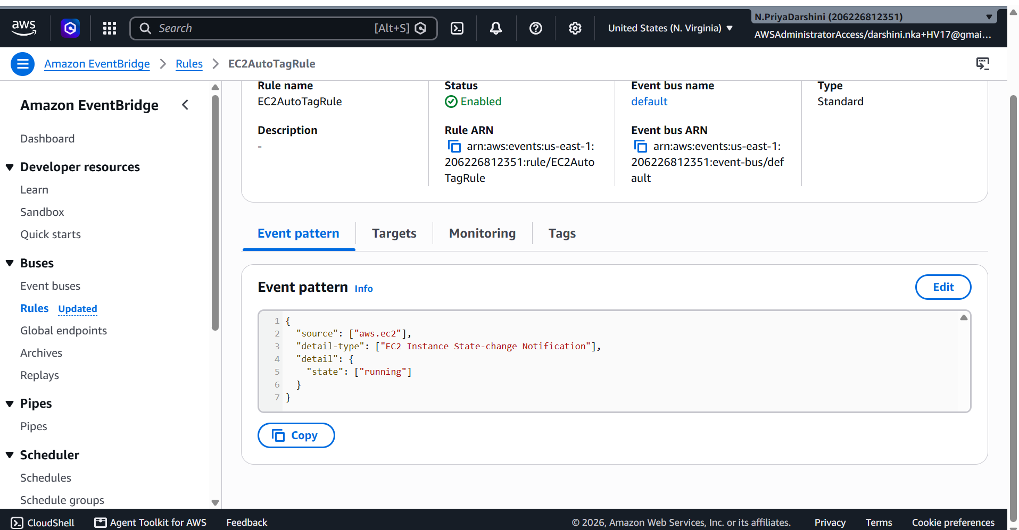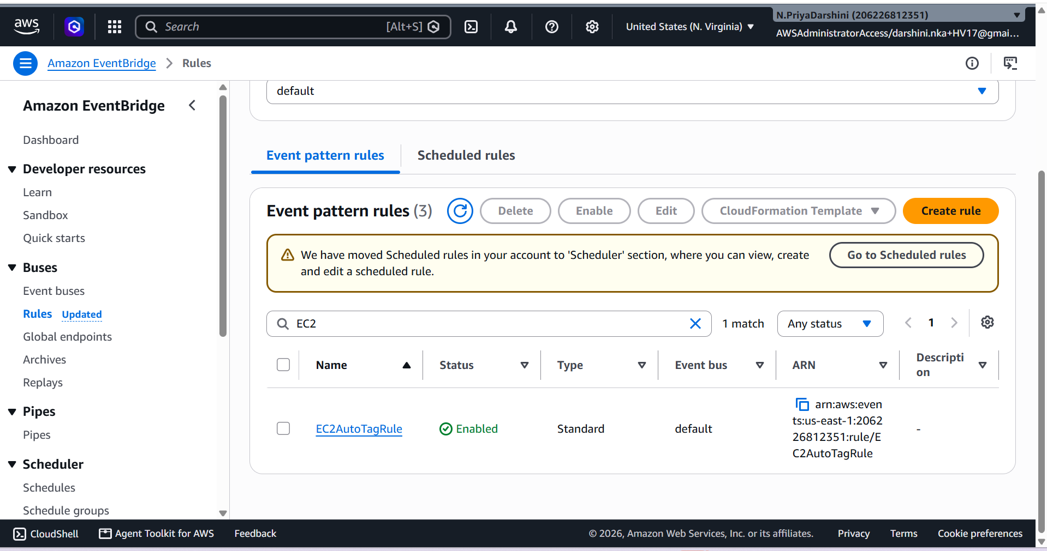

Step 10 – Test the Automation
Launch a new EC2 instance:
- Open EC2 Console.
- Click Launch Instance.
- Select an Amazon Machine Image (AMI).
- Choose an instance type (for example, t2.micro if eligible).
- Complete the launch process.
Wait approximately 30–60 seconds for the instance to enter the Running state and for EventBridge to invoke the Lambda.

Step 11 – Verify Tags
Open:
EC2
→ Instances
Select the newly launched instance.
Open the Tags tab.
You should see:
Key | Value
LaunchDate | 2026-07-22 (example)
Environment | Development
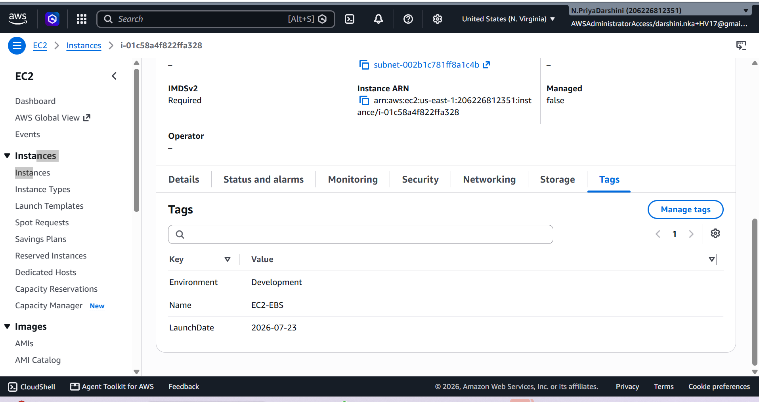

Step 12 – View CloudWatch Logs
Open:
CloudWatch
→ Log Groups
→ /aws/lambda/EC2AutoTag
Example log:
Successfully tagged instance i-0123456789abcdef0

Expected EventBridge Event
Your Lambda receives an event similar to:
{
"version": "0",
"id": "12345678",
"detail-type": "EC2 Instance State-change Notification",
"source": "aws.ec2",
"detail": {
"instance-id": "i-0123456789abcdef0",
"state": "running"
}
}
The Lambda extracts:
instance_id = event["detail"]["instance-id"]

Expected Lambda Response
{
"InstanceId": "i-0123456789abcdef0",
"Status": "Tagged"
}

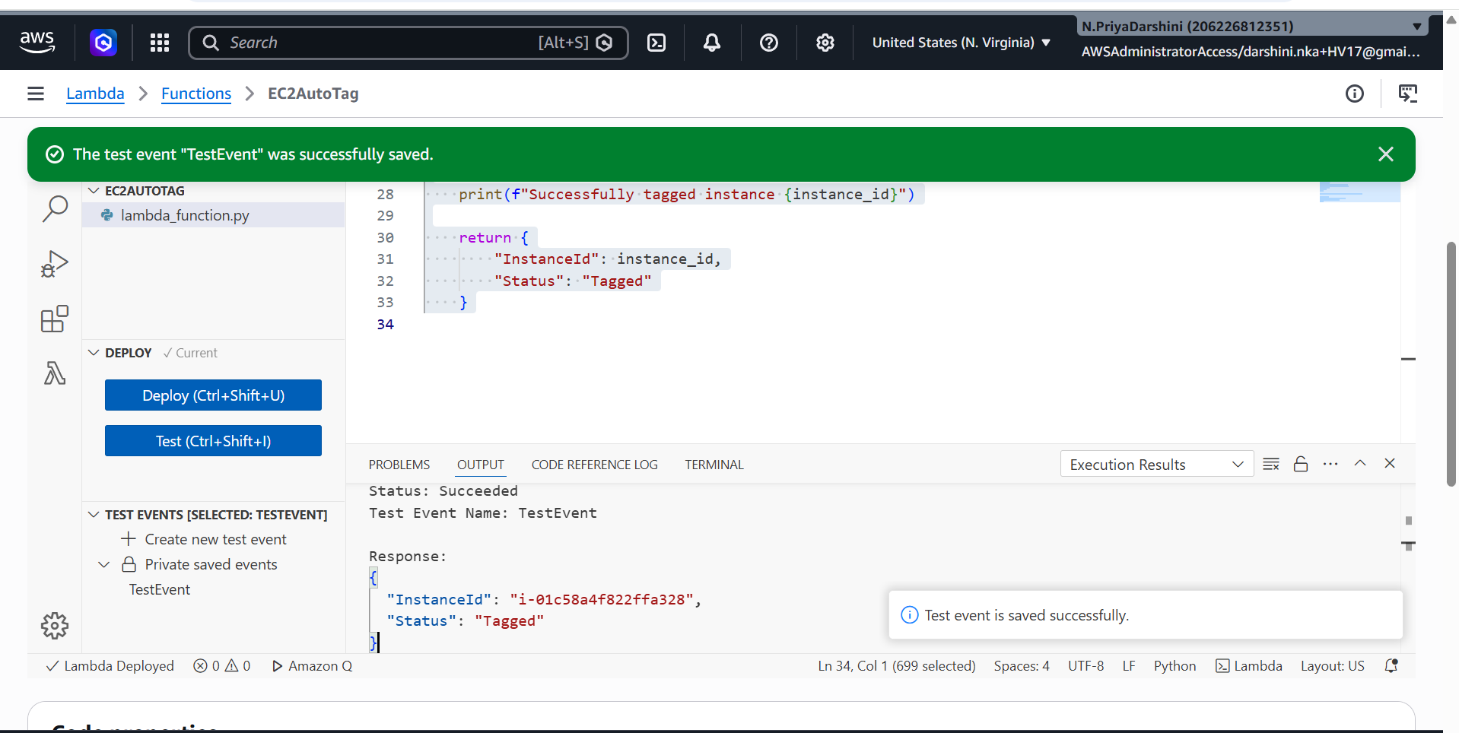

IAM Permissions Used
Permission | Purpose
ec2:CreateTags | Adds tags to EC2 instances
ec2:DescribeInstances | Retrieves instance information if needed
AWSLambdaBasicExecutionRole | Allows Lambda to write logs to CloudWatch

Testing Checklist
Task | Status
IAM role created | ✅
Inline policy attached | ✅
Lambda function created | ✅
EventBridge rule configured | ✅
New EC2 instance launched | ✅
Lambda invoked automatically | ✅
Tags added successfully | ✅
CloudWatch logs verified | ✅

Bonus – Automatically Tag the Launching IAM User
A common interview requirement is to tag the EC2 instance with the IAM user or role that launched it.
Approach
- Enable AWS CloudTrail (if not already enabled).
- Create an EventBridge rule that listens for CloudTrail RunInstances API calls.
- In the Lambda function:
  - Read the instance ID from the CloudTrail event.
  - Extract the IAM identity from the event.
  - Add an Owner tag using that identity.
Example CloudTrail fields:
{
"detail": {
"userIdentity": {
"type": "IAMUser",
"userName": "john.doe"
},
"responseElements": {
"instancesSet": {
"items": [
{
"instanceId": "i-0123456789abcdef0"
}
]
}
}
}
}
Example code snippet:
owner = event["detail"]["userIdentity"]["userName"]

instance_id = event["detail"]["responseElements"]["instancesSet"]["items"][0]["instanceId"]

ec2.create_tags(
Resources=[instance_id],
Tags=[
{
"Key": "Owner",
"Value": owner
}
]
)
This approach automatically records who launched the instance and is frequently discussed in AWS interviews because it demonstrates integration between CloudTrail, EventBridge, and Lambda.

Discussion Point
For organizations with mandatory tagging policies, this EventBridge and Lambda solution ensures every EC2 instance is tagged immediately after launch, reducing manual effort and improving governance. While AWS Organizations Tag Policies can enforce allowed tag values, they do not automatically apply tags. Lambda is the preferred choice when tags need to be populated dynamically based on launch events, IAM identities, naming conventions, or other business logic.

*********************************END***************************************************

